(Approx. 1059 words)

Starlink – It may be in your future
By Phil Sorrentino, Secretary & Newsletter Contributor
Sun City Center Computer Club
https://scccomputerclub.org/
philsorr (at) yahoo.com
Starlink is a satellite constellation built and operated by SpaceX, currently providing satellite internet access coverage to over 53 countries. Starlink is the world’s first and largest satellite constellation using a Low Earth Orbit to deliver broadband internet capable of supporting streaming, online gaming, and video calls. Starlink will become a critical element in the client-server technology used by the internet in many areas worldwide.
Client-server technology is the network architecture that connects our devices to powerful Servers at the far ends of the country and, in some cases, the world. The internet provides this connection, so the devices and servers appear close in adjoining rooms. To make this a reality, the internet connection must be high-speed. This type of internet connection is called a low-latency connection. A connection that is so fast that a message might go from New York to Los Angeles and back in less than .1 seconds (100 ms). Starlink can deliver high-speed, low-latency internet to users worldwide, though it may be a little expensive now.
To take advantage of the Servers on the internet, our devices (computers, smartphones, tablets) must be able to connect. Either of the two mechanisms traditionally does this. If you are stationary, typically in a building, you can connect to the internet through your Internet Service Provider and more than likely connect via a wireless wi-fi network. If you are moving in a vehicle, you can connect through your Wireless Internet Provider via the Cell Towers in all major populated areas and along most major highways in the US. Access to the internet is excellent in the US. Ninety percent of the people in the US have an internet connection available to them. New Jersey and Connecticut have the best broadband coverage at about 99%. As expected, the major cities, Washington DC, Philadelphia, San Francisco, and New York, have the highest internet participation. But the rest of the world is not covered very well. Europe has a participation rate of about 90%, but the numbers are much lower for underdeveloped countries like India at about 48% and China at about 70%. With all things considered, worldwide internet participation is reported to be about 60%, which leaves a large population without access to the internet.
The Starlink satellite constellation currently has around 4,500 satellites and will eventually have around 12,000. They will cover most of the earth, providing an internet connection to any site with a direct view of the satellites as they pass overhead. Think of the satellites as Cell Towers in the Sky.
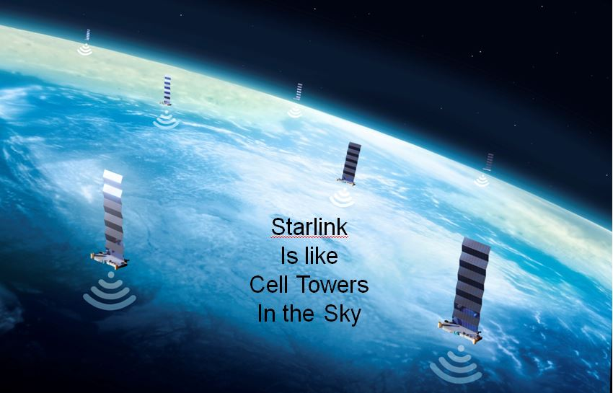
The Starlink satellites are in Low Earth Orbit (LEO), about 340 miles above the earth, and have a speed that creates a 90-minute orbit around the planet, about 17,000 mph. When the constellation is entirely built out, a satellite will be accessible by almost every place on the earth. A device will send/receive data to/from the internet via the Starlink Transponder, overhead satellite, other satellites, and finally, the Starlink Gateway (Ground Station). The connection of the Starlink transponder to the overhead satellite will continue until the satellite moves out of view and another satellite comes into view. At this time, the connection from the transponder will switch to the new satellite, and the data flow will continue.
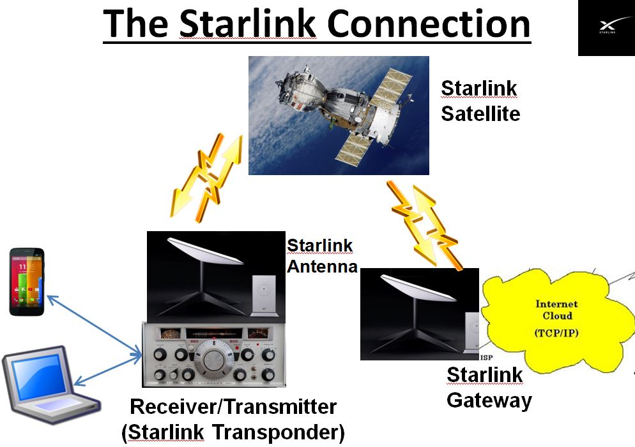
The Starlink Transponder controls tracking the satellites when they are in view and switching the data stream to a new satellite. The heart of the transponder is a sophisticated computer-controlled phased array antenna system.
Phased array antennas are a key component of the Cell Tower Communications systems we use as we travel on the Interstate highway. The phased array antenna was invented by Karl Ferdinand Braun in 1905. The initial experimental antenna was a three-element array that transmitted a beam whose direction could be aimed electronically in 3 specific directions, 120 degrees apart. The military experimented with phased arrays in the 1970s, the first industrial phased array systems were introduced in the 1980s, and Cell Tower antennas appeared in the 1990s. Today’s phased array antennas have large numbers of elements and can form several very narrow beams and steer them independently in very small angle increments. The technology behind phased array systems is steeped in the propagation of electrical energy from Gauss’s laws for static electric and magnetic fields to Maxwell’s equations that relate electric and magnetic fields to each other. It is a collection of technology concepts that would make Nikola Tesla proud.
Just a little technical talk. A phased array antenna is a collection of antenna elements assembled such that the radiation pattern of each element constructively combines with neighboring antennas to form an effective radiation pattern called the main lobe. The main lobe transmits radiated energy in the desired direction, while the antenna is designed to destructively interfere with signals in undesired directions, forming nulls and side lobes. The antenna array is designed to maximize the energy radiated in the main lobe while reducing the energy radiated in the side lobes to an acceptable level. The radiation direction can be manipulated by changing the amplitude and phase of the signal fed into each antenna element.
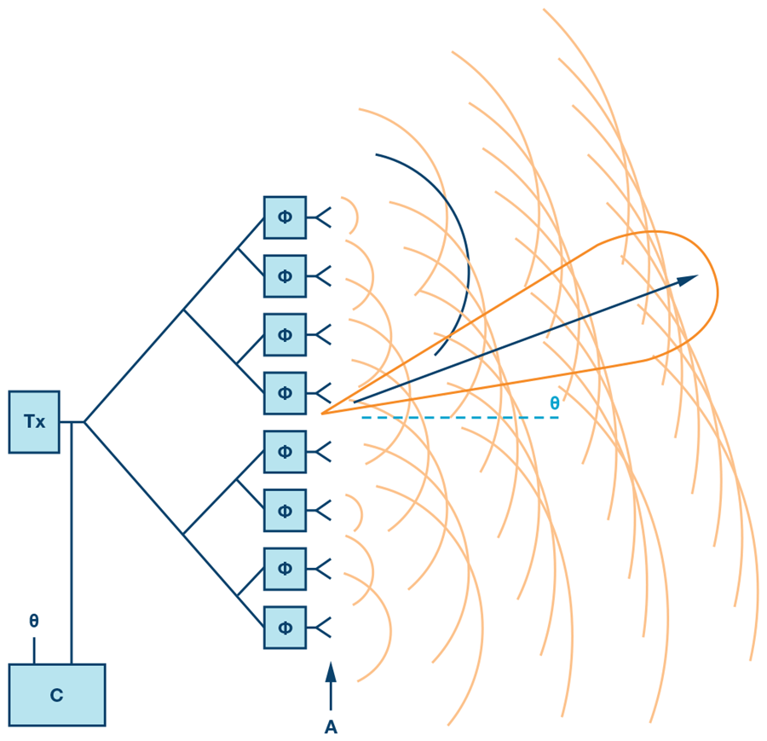
Phased Array pattern showing antenna elements creating a central lobe.
As we travel down the highway, the closest cell tower tracks us with a phased array antenna that allows us to connect to the internet. The tracking allows the Cell Tower System to transition a vehicle to the next Cell Tower in the direction the vehicle is moving, thus allowing the communications to continue uninterrupted as the vehicle is handed off from cell tower to cell tower. This is all coordinated using the phased array antennas on the Cell Towers.
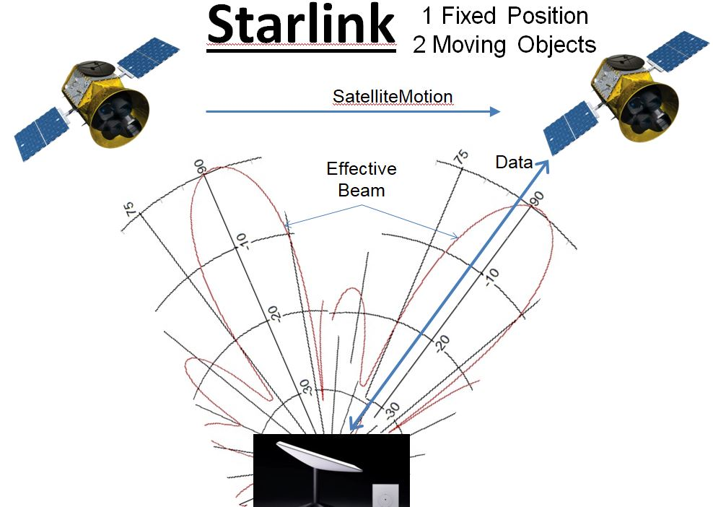
This cell tower hand-off is similar to the hand-off used to transition from one satellite to another as the satellites move in the sky. The phased array antenna in the Starlink Transponder tracks the satellites and coordinates the hand-off when needed so that the communications continue without interruption.
Starlink is an enormous project that combines many technologies to hopefully provide global access to the internet so that we all can take advantage of the Servers at the other end of the internet, just as if they were in the adjoining room. It may just be in your future.

